Section II. 11BCHM30 Tasks

BASIC TACTICS

DIRECT A DRIVER OVER A TERRAIN ROUTE
071-326-3001

CONDITIONS

Given a tactical vehicle, a driver, a 1:50,000-scale topographic map of the area, an enemy situation, and a mission to move from one point to another.

STANDARDS

Select the best route from one point to another and direct the movement of the vehicle over this route, observing all terrain driving rules.

TRAINING AND EVALUATION
Training Information Outline

CAUTION
During training, follow installation SOP or local guidelines concerning cross-country vehicle travel.

1. Give the driver clear, specific instructions as to the route that affords the best use of available cover and concealment (Figure 1).

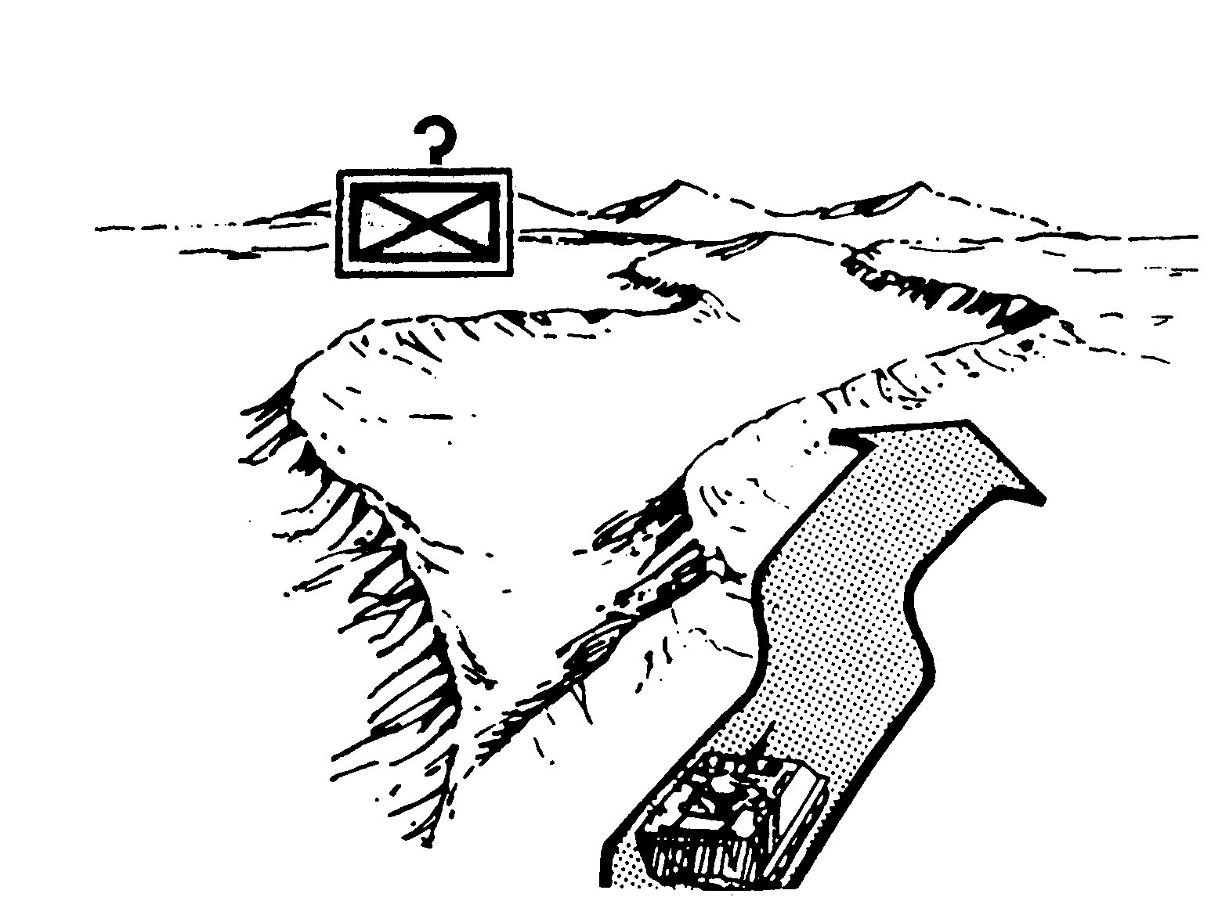
SELECTED
ENEMY
POSITIONS

Figure 1. Choose route cover and concealment.
2. Follow these terrain-driving rules to reduce exposure to effective enemy fire and detection:
a. Never skyline or move directly forward from a defilade or hull-down firing position (Figure 2).

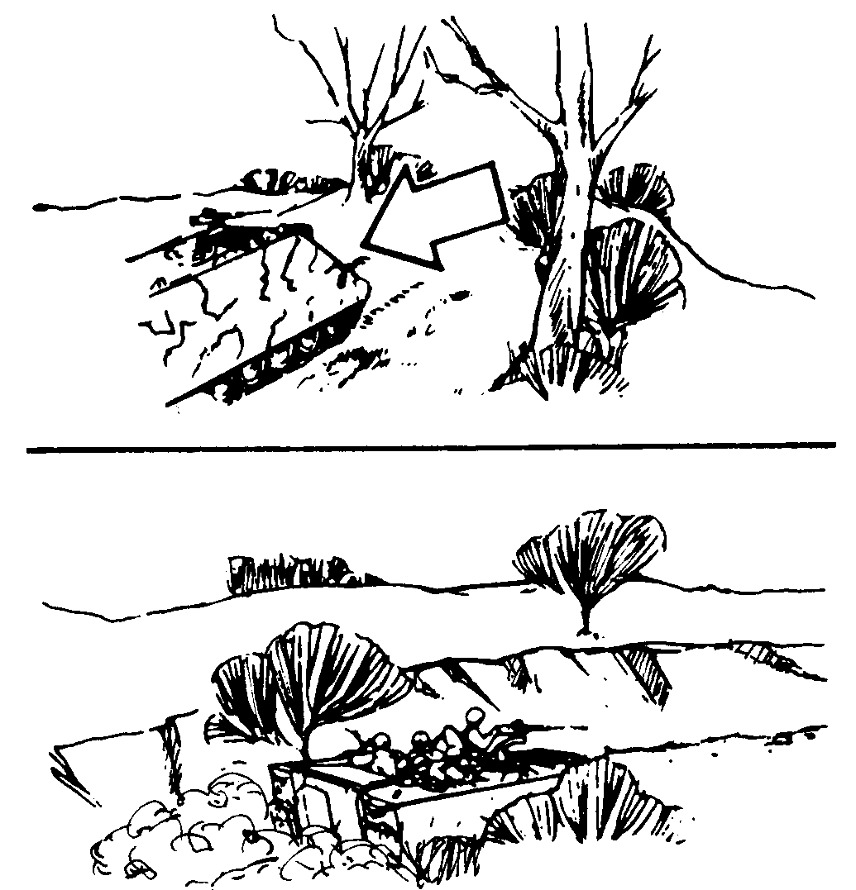

Figure 2. Move from defilade or hull-down firing position.

b. Avoid dusty terrain when possible, since it betrays the movement of armored vehicles (Figure 3).

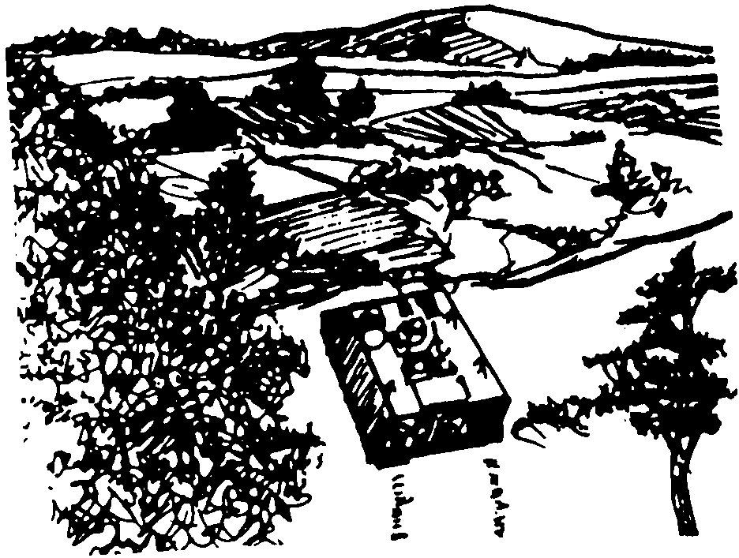

Figure 3. Select terrain.

c. Use all available cover and concealment.
d. Try to leave the terrain looking as natural as possible to make tracking by the enemy harder (Figure 4).

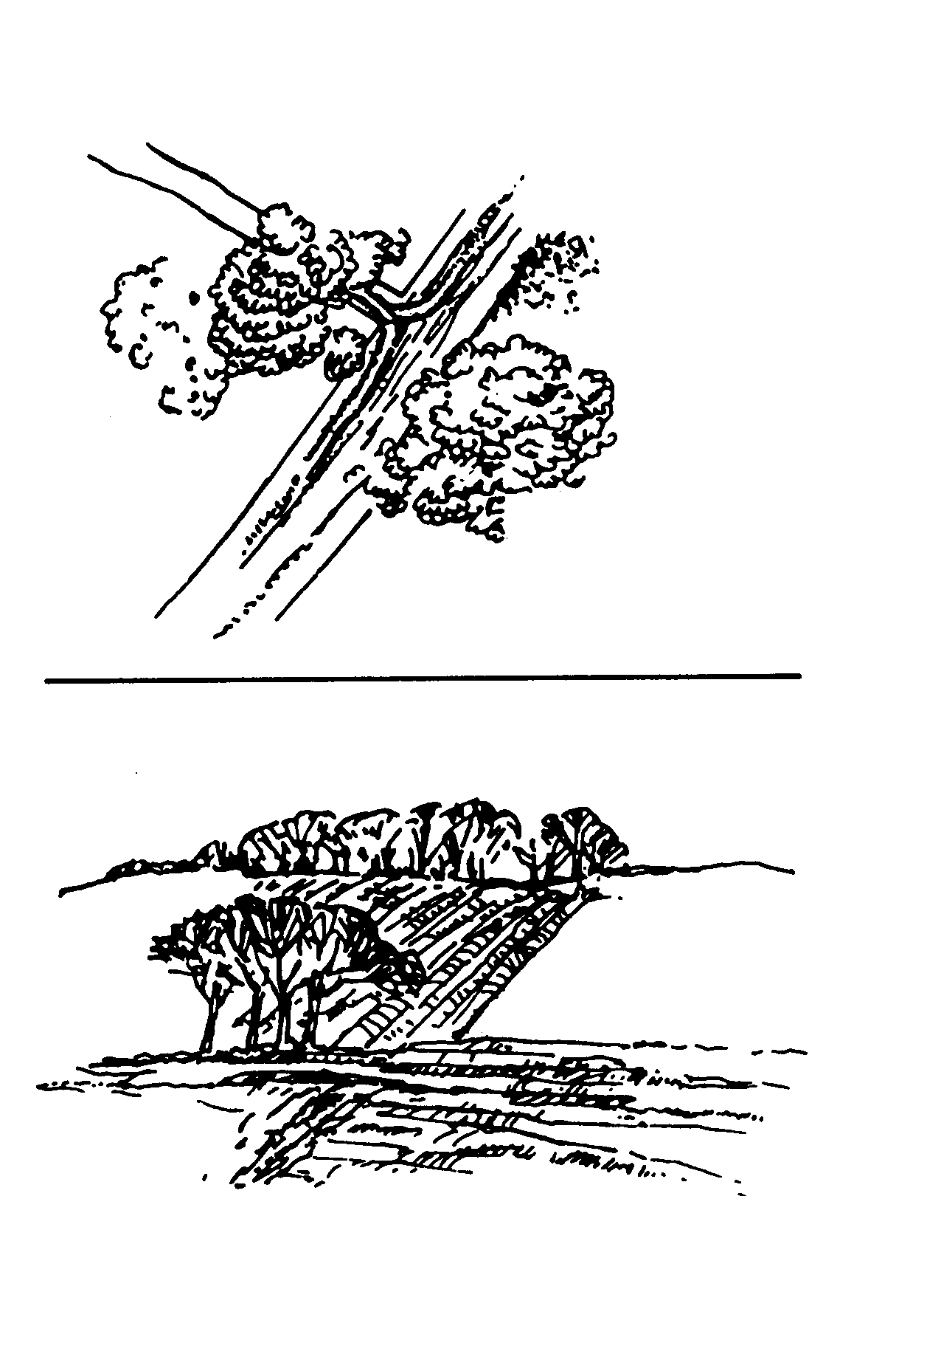
KEEP TO THE ROAD WHEN
TURNING CORNERS
CUT CORNERS SHOW
VEHICLE MOVEMENT INTO
WOODS.
USE TERRAIN TO HIDE TRACKS
VEHICLE MOVES ALONG SINGLE
TRACK USING TERRAIN TO HIDE
MOVEMENT.

Figure 4. Hide tracks.

e. To cross an open area (as when emerging from a wood line, crossing a ridge, and so forth), check it first for possible enemy positions, then cross it quickly (Figure 5). If enemy locations are identified or suspected, suppress or smoke them before crossing. Cross the open area as quickly as possible from one covered position to the next.

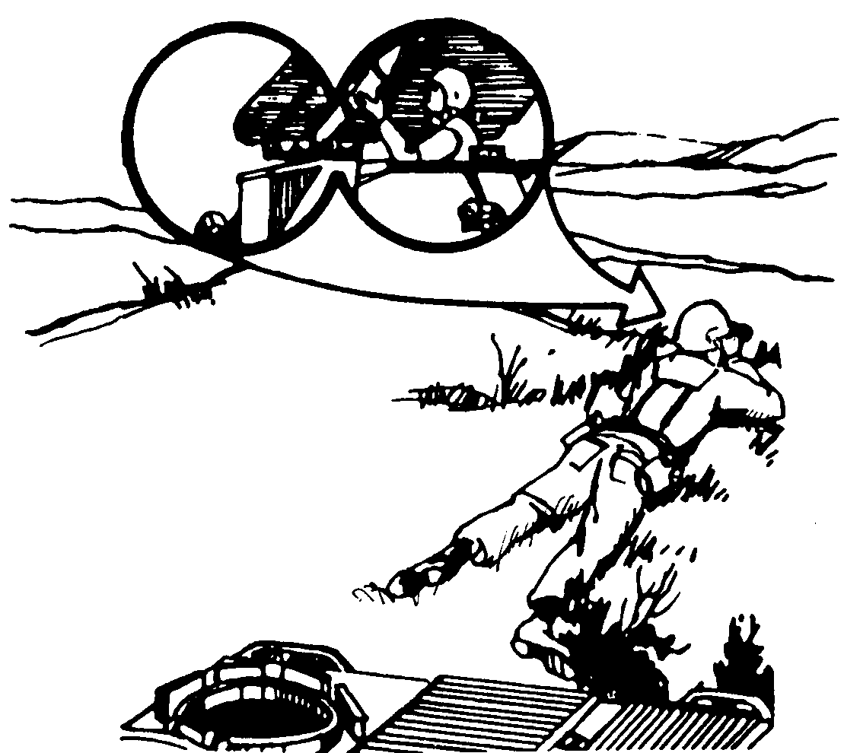

Figure 5. Plan routes.

f. Where covered or concealed routes are not available, or when their use would be time consuming, plan routes that have “escape valves” available (Figure 6). The figure shows how a dense tree line provides protection from Saggers.

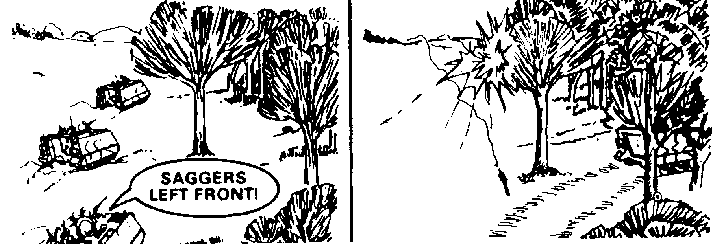

Figure 6. Use terrain.

EVALUATION PREPARATION

Setup: At the test site, provide a vehicle, driver, map, and all information given in the task conditions statement.

Brief Soldier: Tell the soldier to select the exact terrain route for the vehicle and direct the driver over the route. The soldier will be given the enemy situation, the mission, a vehicle, and a driver to move from one point to another.

EVALUATION GUIDE

Performance Measures Results

1. Give clear and specific instructions as to routes that afford
the best cover and concealment. P F

2. Follow the correct terrain driving rules. P F
a. Do not skyline or move directly forward from a defilade
or hull-down firing position.
b. Avoid dusty terrain.
c. Use available cover and concealment.
d. Leave terrain looking as natural as possible.

3. Use proper procedures to cross open areas. P F

4. Plan routes with escape valves available. P F

FEEDBACK

Score the soldier GO if all steps are passed. Score the soldier NO-GO if any steps are failed. If the soldier fails any steps, show what was done wrong and how to do it correctly.

REFERENCES

Required Related
None FM 7-7
FM 7-7J

